Pre-Calculus 11
Chapter 7 ~ Absolute Value & Reciprocal Functions

Learning Outcomes ~ Student can:
A1 | graph absolute value functions, write piecewise functions, and solve absolute value equations.
R5 | graph reciprocals of linear and quadratic functions, write equations for asymptotes, and identify invariant points.

Date | Topic
Friday,  November 22 | Graphing Linear & Quadratic Equations Review (worksheet)  Lesson 7.1 ~ Absolute Value  (Absolute Value Worksheet and pg 363 #2, 3, 5, 8, 11)
Tuesday,  November 26 | Lesson 7.2 ~ Absolute Value Functions  (pg 375 #2, 3, 4, 6, 8, 9, 10, 11)  Lesson 7.3 ~ Absolute Value Equations  (pg 389 #2, 4 – 7, 9, 11, 16, 17)
Thursday,  November 28 | Quiz 7.2 & 7.3  Lesson 7.4 ~ Reciprocal Functions  (Reciprocal Graphs Worksheet and pg 403 #1, 2, 3, 7, 8, 10)
Monday,  December 2 | Quiz 7.4  Review (pg 410 - 414)
Wednesday,  December 4 | Chapter 7 Test
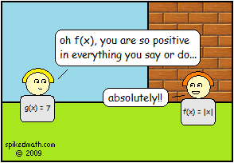

New Vocabulary

Term | Definition | Example
Absolute
Value
Absolute Value Function
Piecewise Function
Invariant
Point
Absolute Value Equation
Reciprocal Function
Asymptote

