Pre-Calculus 11
Chapter 6 ~ Rational Expressions & Equations

Learning Outcomes ~ Student can:
R3 | simplify and perform order of operations with rational expressions, and identify non-permissible values.
R4 | solve rational equations algebraically, and identify extraneous roots.

Date | Topic
Thursday,  November 7 | Lesson 6.1 ~ Rational Expressions  (Worksheet "Books Never Written" & pg 317 #3, 4, 5, 11, 13,  14, 15, 19)  Lesson 6.2 ~ Multiplying & Dividing Rational Expressions  (pg 327 #1, 2, 4, 8, 10, Worksheet "What Happens When…" &  pg 327 #14, 15, 16)
Tuesday,  November 12 | Quiz 6.1 & 6.2  Lesson 6.3 ~ Adding & Subtracting Rational Expressions  (pg 336 #1, 3, 5, Worksheet "Did You Hear About…" & pg 336  #7 - 10, 15, 16, 18)
Thursday,  November 14 | Quiz 6.3  Lesson 6.4 ~ Rational Equations  (Worksheet "Did you Hear About…", "Sheep" & pg 348 #5 - 9,  12, 13, 14, 17, 19, 20)
Monday,  November 18 | Quiz 6.4  Review (pg 352 - 355)
Wednesday, November 20 | Chapter 6 Test

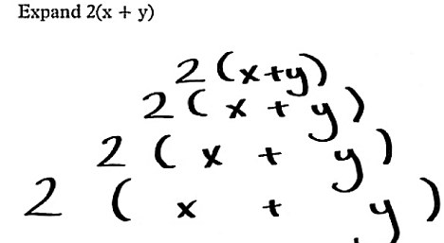
New Vocabulary

Term | Definition | Example
Rational Expression
Non-Permissible Value
Rational Equation

