Pre-Calculus 11
Chapter 5 ~ Radical Expressions & Equations

Learning Outcomes ~ Student can:
R1 | simplify, order, and perform order of operations with radical expressions.
R2 | solve radical equations algebraically and graphically, and identify domain restrictions and extraneous roots.

Date | Topic
Wednesday,  October 23 | Grade 10 Prime Factorization Review Worksheet
Monday,  October 28 | Lesson 5.1 ~ Working With Radicals  ("Sing" & "Elephants" worksheet & pg 278 #1, 4, 6, 11, 14, 17) Lesson 5.2 (part 1) ~ Multiplying Radicals  ("What Do You Get" worksheet & pg 289 #1de, 2cd, 3cd, 5)
Wednesday,  October 30 | Quiz 5.1 & 5.2 (part 1)  Lesson 5.2 (part 2) ~ Dividing Radicals  ("Did you hear" worksheet & pg 290 #7, 8bc, 10, 11, 15, 17, 21)  Lesson 5.3 ~ Radical Equations  ("Cake" & "Physics" worksheet & pg 301 #9cd, 10cd, 13, 15)
Friday,  November 1 | Quiz 5.2 (part 2) & 5.3  Review (pg 304 - 307)
Tuesday,  November 5 | Review  Chapter 5 Test

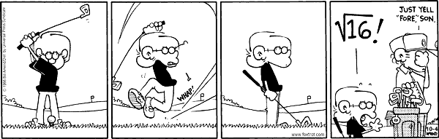

New Vocabulary

Term | Definition | Example
Rationalize
Conjugates
Radical Equation

