Pre-Calculus 11
Chapter 9 ~ Linear & Quadratic Inequalities

Learning Outcomes ~ Student can:
Q5 | solve linear and quadratic inequalities in one variable, and state domain and range restrictions for word problems.

Date | Topic
Thursday,  October 17 | Lesson 9.2 ~ Linear and Quadratic Inequalities in One Variable  ("Crossword Puzzle" & "Professor" worksheet, and pg 484  #1 - 3, 8 - 10, 12, 13, BONUS: 14, 15)
Monday,  October 21 | Quiz 9.2  Review (pg 502 #6 – 10, pg 504 #3, and pg 505 #7, 13)
Wednesday,  October 23 | Chapter 9 Test

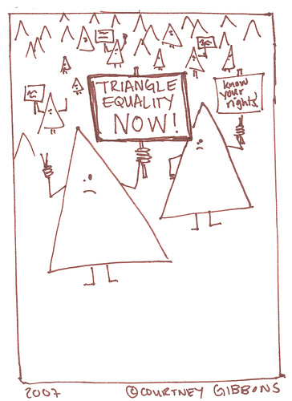

New Vocabulary

Term | Definition | Example
Solution Region
Boundary
Test Point

