Foundations of Math & Pre-Calculus 10
Chapter 2 ~ Trigonometry

Learning Outcomes ~ Student can:
T1 | solve for missing sides and angles of right triangles using tangent, sine, and cosine ratios.
T2 | solve word problems involving right triangles.

Date | Topic
Friday, January 30 | Pythagorean Theorem Review  (worksheet: "What is the Title" & "How Do You Write A Song")
Tuesday,  February 4 | Pythagorean Theorem Review Quiz  Lesson 2.1 & 2.4 ~ The Sine, Cosine, & Tangent Ratios  (pg 75 #3, 4, 5, 10, 13, 14, 17, 18, 19)  (pg 95 #4, 5, 6, 8, 12, 13, 14)
Thursday,  February 6 | Quiz 2.1 & 2.4  Lesson 2.2 & 2.5 ~ Using the Sine, Cosine, & Tangent Ratios to  Calculate Lengths  (pg 82 #3, 5, 6, 8, 11, 13, 14)  (pg 101 #3, 5, 6, 7, 8, 9)
Monday,  February 10 | Quiz 2.2 & 2.5  Lesson 2.6 ~ Applying the Trigonometric Ratios  ("Orbit" & "Decoder" worksheets & pg 111 #6, 8, 9, 10, 12)  Lesson 2.7 ~ Solving Problems Involving More than One Right  Triangle (pg 118 #3, 4, 5, 6, 8, 11, 13, 16)
Wednesday,  February 12 | Quiz 2.6 & 2.7  Review (pg 124 #1, 3, 5 - 9, 11, 13 - 23)  **to be handed in on day of test**
Friday,  February 14 | Chapter 2 Test

* Bold, italicized numbers represent the word problems to practice for outcome T2.

*Need a challenge? Try the "C" questions at the end of each section!

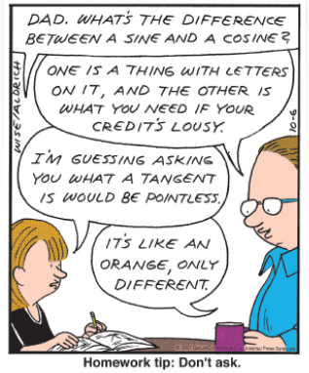
http://vargageo.weebly.com/uploads/5/7/1/0/57104145/8427214_orig.png
New Vocabulary

Term | Definition | Example
Indirect
Measurement
Tangent
Ratio
Sine
Ratio
Cosine
Ratio
Angle of
Inclination
Angle of
Elevation
Angle of Depression

